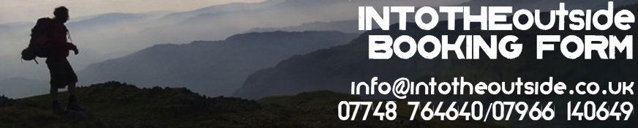
As INTO THE OUTSIDE will be responsible for your wellbeing, we require each individual to complete this form and return it by email to info@intotheoutside.co.uk BEFORE the day of your activity (Please complete ALL SECTIONS in CAPTIALS)

ACTIVITY: |  | DATE(S):
WHERE DID YOU HEAR ABOUT US? |  | PRICE:

Your details:
TITLE: |  | FIRST NAME: |  | SURNAME:
ADDRESS
& POST CODE:
MOBILE NUMBER: |  |  |  | DATE OF BIRTH:
EMAIL:

Next of Kin: (Someone not on the adventure)
TITLE: |  | FIRST NAME: |  | SURNAME:
MOBILE NUMBER:

Medical Information form:

Have you been a hospital patient during the past 12 months? YES/ NO
Have you received doctor’s treatment during the past 12 months? YES/ NO
Are you receiving or waiting for hospital treatment? YES/ NO
Do you suffer from any allergies? YES/ NO
Have you ever suffered from; heart disease, high blood pressure, asthma, epilepsy, diabetes? YES/ NO
Are you taking any drugs or other medication? YES/ NO
Have you ever had problems with your back or with any joints (knees etc)? YES/ NO
Is there anything else you feel INTO THE OUTSIDE should be made aware of? YES/ NO

If you have answered YES to any question please give details in the below.

Are you confident swimming 50 metres? (only complete if doing a water-based activity) YES/NO
The photos we take on your adventure may be used on our website! Is this OK? YES/NO
Can we contact you again to share upcoming adventures? YES/NO

Minimum Age

Under 18’s must be accompanied by a parent or guardian.

Participation Statement

INTO THE OUTSIDE recognise that their adventures involve activities with a danger of personal injury or death. Participants should be aware of and accept these risks, and be responsible for their own actions and involvement.

Booking form declaration

• By signing you are agreeing to INTO THE OUTSIDE’s terms & conditions (on website) and participation statement (above)
• By signing you confirm that the medical information provided above is complete, current and accurate

SIGNED: |  | PRINT NAME: |  | DATE:
Ambleside, Cumbria, LA22 0DB, UK. Tel: 015394

